 **Mount Lawley Senior High School**

**Year 8 Biological Sciences**

***End of Term Test 20******21***

**Section 1: Multiple Choice Answers – 1 mark each (TOTAL 29 MARKS)**

*Read all answers and choose the* ***BEST*** *one.*

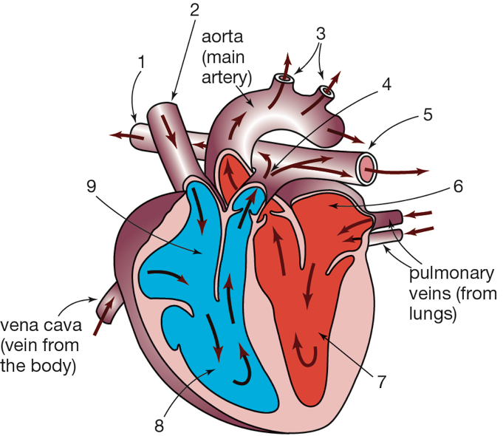1. Use the information in this diagram of the human heart to identify the correct  
 statement from the list below.

1. Blood travels to the lungs from 3 and returns into 9.
2. Blood travels to the body from 5 and returns into 6.
3. Blood travels to both lungs from 5 and returns to the heart through 2.
4. Blood travels to the body from 3 and returns to the heart through 2.

2. Which of the following is a body system?

1. A group of similar cells doing the same function.
2. A group of different tissues working together to perform a function.
3. A group of organs acting together to carry out a function.
4. A group of systems co-operating to ensure the survival of the individual.

3. 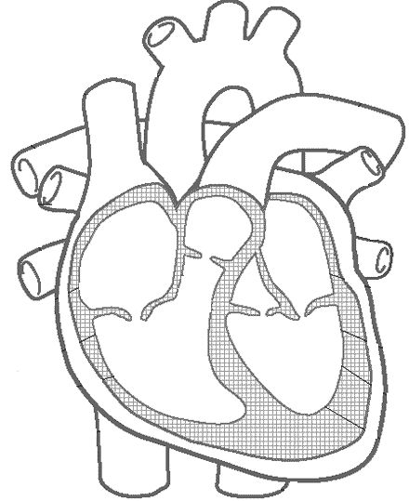Choose the answer that correctly labels the heart diagram **from A🡪D**

1. Right Ventricle, Right Atrium, Left Ventricle, Left Atrium
2. Left Atrium, Left Ventricle, Right Atrium, Right Ventricle
3. Right Atrium, Right Ventricle, Left Atrium, Left Ventricle

A

C

1. Left Ventricle, Left Atrium, Right Ventricle, Right Atrium

D

B

4. What are capillaries?

1. The smallest blood vessels of the circulatory system.
2. The medical name for heart muscle cells.
3. Small lumps of fatty tissue that can clog blood vessels.
4. Cells that guard against infection

5. The circulatory system is composed of:

1. The heart, blood, and blood vessels.
2. The heart, the brain, and the lungs.
3. The lungs, the blood, and the blood vessels.
4. The brain, the heart, and the blood vessels.

7. What is your heart made of?

1. Skin
2. Tissue
3. Muscle
4. Carbon

8. What happens in the mouth during digestion?

1. Teeth break down food mechanically using enzymes.
2. Teeth break down food chemically, mixing saliva with the food for easier digestion.
3. Saliva breaks down food chemically using enzymes.
4. a and c.

9. Select the list that shows the level of organisation from most complex to least complex.

1. organelle → cell → tissue → organ → organ system
2. cell → organ system → tissue → organelle → organ
3. organ system → organ → tissue → cell → organelle
4. tissue → organelle → organ → cell → organ system

10. Bile is made in the _____________ and stored in the ________________.

1. gall bladder, small intestine
2. liver, gall bladder
3. pancreas, small intestine
4. gall bladder, liver

11. Most of the absorption of nutrients occurs in the ______________.

1. stomach
2. small intestine
3. liver
4. large intestine

12. Peristalsis occurs in the digestive tract in:

1. the esophagus, small intestine, and large intestine only
2. the small and large intestines only
3. the stomach and small intestine only
4. from the pharynx to the rectum

13. Which selection includes only accessory organs that are part of the digestive system?

1. salivary glands, thyroid gland, pancreas, liver
2. stomach, duodenum, pancreas, gallbladder
3. gallbladder, liver, pancreas, salivary glands
4. liver, thyroid gland, gallbladder, spleen

14. Which of the following statements is NOT true?

1. Arteries – transport blood away from the heart.
2. Arteries – return blood from the tissue to the atria.
3. Capillaries – site of exchange of substances between blood and tissue fluid.
4. Veins – rely on muscle contraction to assist blood movement.

15. What happens when food reaches the stomach?

1. Nothing. No digestion occurs in the stomach.
2. The food moves quickly into the small intestine.
3. Juices mix with the food and stomach muscles squeeze it.
4. The food is completely digested and is absorbed by tiny blood vessels in the walls of the stomach.
5. 16. What is the function of the villi in the small intestine?
6. To decrease the amount of exposed surface.
7. To help spread the enzymes over a larger area.
8. To increase the surface area for absorption.
9. To sweep particles across the surface with wavelike actions.

17. Our throat divides into two separate tubes: one for the digestive system, the other for the respiratory system. What prevents food from entering the lungs?

1. The pharynx
2. The tongue
3. The trachea
4. The epiglottis

18. Which one of the following describes a vein?

1. It has thin walls and carries oxygenated blood away from the heart.
2. It has thick walls with valves and carries blood under pressure.
3. It has a very thin wall with valves and carries blood under pressure.
4. It has thin walls with valves, and carries blood to the heart

19. Which blood vessel carries blood from the heart to all parts of the body?

1. Vena cava
2. Anterior cardiac vein
3. Aorta
4. Right coronary artery

23. Three of the following statements are true statements about specialised cells. Identify the ***incorrect*** statement.

1. Specialised cells have a specific job to do in the body.
2. Muscle cells are specialised cells that you use to move around.
3. Root hairs are specialised cells on plant roots that assist water intake.
4. Unicellular organisms are highly specialised cells

24. Which of the following does not produce (make) digestive enzymes?

1. Pancreas
2. Salivary glands
3. Stomach
4. Liver

25. This graph shows that the breathing rate increases when you start exercising but that it does not necessarily continue to increase as you continue to exercise.

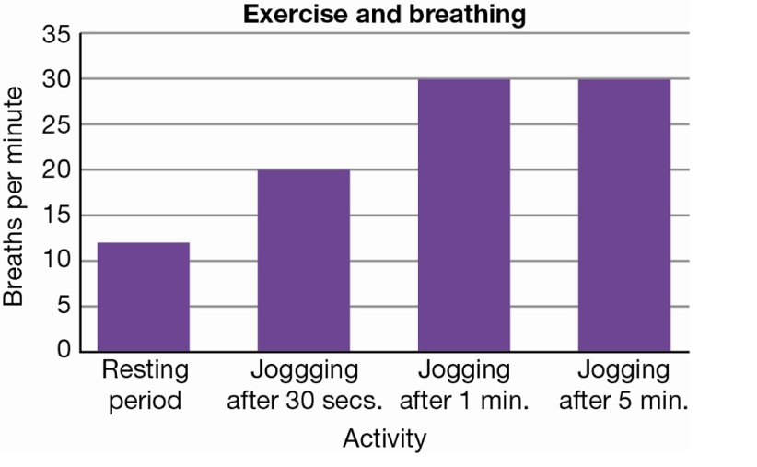

Identify the statement that *cannot* explain the data in the graph.

1. As you start to exercise, your breathing rate increases because you need more oxygen for your muscles to work.
2. Physical activity produces more carbon dioxide in your body and you have to get rid of it.
3. When you do a lot of exercise you breathe more deeply and you do not have to breathe as often.
4. When yo u are exercising at a constant rate your breathing rate becomes constant.

26. Each time the heart beats, a pulse can be felt in;

1. A vein.
2. A capillary.
3. An artery.
4. An aorta.

27. Gastric juices in the stomach:

1. Kill bacteria.
2. Work together to digest food.
3. Include hydrochloric acid.
4. All of the above.

28. By the time the food leaves the stomach it is:

1. A creamy paste called chyme.
2. Rolled in a bolus.
3. Ready to be mixed with pepsin for protein digestion.
4. None of the above.

29. Chemical digestion of starch food begins in the;

1. Mouth.
2. Stomach.
3. Small intestine.
4. Large intestine.

**End of Multiple Choice.**

**Please move on to the Short Answer Section.**

***Section 2: Short Answers***

***The human circulatory system is referred to as a double system.***

1a. Describe the difference between the blood that is pumped to the lungs and the blood that is pumped to the rest of the body. *(Think in terms of the types of gases in the blood)*   
 (2 marks)

Blood to lungs is low in oxygen & high in carbon dioxide (Deoxygenated) (1)

Blood to body is high in oxygen and low in carbon dioxide (Oxygenated) (1)

_____________________________________________________________________________________

_____________________________________________________________________________________

_____________________________________________________________________________________

b. Explainwhat is meant by a double system. (2 marks)

There are two separate circuits through which the blood flows.

Blood goes to lungs (1) Blood goes to the rest of the body (1)

_____________________________________________________________________________________

_____________________________________________________________________________________

2. Complete the below table by Calculating the Total Magnification: (1 mark)

|  |  |  |
| --- | --- | --- |
| Eye Piece  Magnification | Objective lens  Magnification | Total  Magnification |
| 10x | 25x | 250 |
| 10x | 40x | 400 |

3. Match the terms below with the definition, by writing the number in the box.

(4 marks)

|  |
| --- |
| 4 |
| 3 |
| 1 |
| 2 |

Tissues 1. The building block of all living things.  
System 2. A structure that contains at least two different

Cells types of tissues that work together to perform task.  
Organ 3. Two or more different organs that work together.

4. A group of cells that performs the same function in the body.

4. Complete the table below: (5 marks)

|  |  |
| --- | --- |
| **Specialised cell** | **Function** |
| Nerve Cells | Carry messages throughout the body. |
| Red blood cells | Carry **Oxygen** throughout the body. |
| Conducting/Xylem cells | Transports water from the roots to the leaves and sugar to the roots from the leaves. |
| Muscle Cells | Allow body to **move** through **contracting and expanding** |
| Photosynthetic cells | Stores chlorophyll to allow for photosynthesis to occur. |

**5. Label** the following diagram: (4 marks)

(1/2 mark each)

6. Name six things transported by the circulatory system. (3 marks)

Oxygen, carbon dioxide, nutrients, glucose, hormones, waste, plasma, platelets, red & white blood cells, enzymes

_____________________________________________________________________________________

_____________________________________________________________________________________

_____________________________________________________________________________________

7. Label the organs of the digestive system. (5 marks)

Salivary Glands

Mouth

Oesophagus

Stomach

Liver

Pancreas

Small Intestine

Large Intestine

Rectum

Anus

**THE END**

**Multiple Choice / 29**

**Short Answer / 26 TOTAL / 55**